
DoneForMeSpaMarketing.com
May 2016
Your Day Spa E-zine

A note from Victoria

May is a very special time of the year! We have many great things planned for you this month!

We start the month off by celebrating Cinco de Mayo, then Teachers Day! There are many great teachers who impact our lives and the lives of our children. To help recognize them this month, we invite you to nominate your children’s favorite teacher for a make-over. Read more below.

Then, we celebrate Mother’s Day the second Sunday in May. Mother's Day is one of my favorite days of the year. Read the article, Great Gift Suggestions for Mom!

Last but certainly not least, on May 30th we celebrate Memorial Day. It is the day dedicated to service men and women who gave their lives for freedom and our country. It is also a time to remember loved ones who have passed away and be thankful for all of our blessings.

Check out all the great promotions we have listed below!

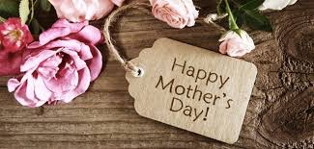
From the entire team, enjoy this e-zine and have a happy May!


Mother’s Day Promotions

Give mom the gift she will love!
Choose one of the following gifts:

- Annual Spa Membership (receive the 12th month for free)
Mom will enjoy coming to the spa for her favorite monthly massage, facial or manicure & pedicure.

- A $500 gift card – receive $50 for free

- A $250 gift card – receive $25 for free

- Or pick your own gift card amount and let us customize it for you!

Purchase now link to GC page
http://www.avenuedayspa.com/gifts.php



Mango May Mothers Day Promotions


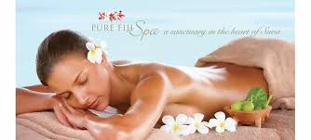
Mango Body Treatment $225

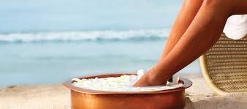
Restore your skin to a healthy glow with this unique exfoliating and hydrating treatment using coconut mango and natural cane sugar.Treat mind, body and spirit with Pure Fiji's blend of exotic oils infused with therapeutic essential oils and mango fruit help to restore balance, soothe mind and body while moisturizing and replenishing the skin with much needed nutrients. A combination of massage techniques is used to relieve muscle tension and restore harmony and inner peace.

Mango Spa Mani/Spa Pedi $110
Revive your hands with the magic touch of the islands. Includes a sugar rub and warm body butter masque for silky smooth hands.
Save your soles with this popular ritual. Indulge in a coconut sugar rub and foot massage followed by a warm body butter masque.

Mango Magic Facial $ 125
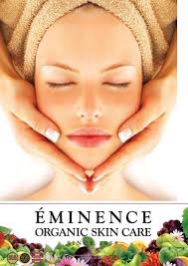
Ease the appearance of fine lines and fatigue with this puree of mango, coconut and rich shea butter. Plus, prevent dehydration with a protective shield of algae and Tara Tree.

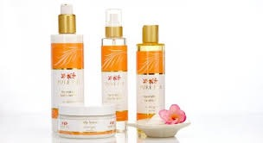

Available for home care Purchase now!
http://www.avenuespastore.com/categories.asp?cID=73

Nominate your children's teacher to win a make-over
Go to Avenue Apothecary & Spa Facebook and submit your entry.

Take a picture of you and your children's teacher, post it on facebook, tell us why you like her or him so much and why you are nominating them.
We will choose a winner on May 15th.
The Winner will receive:
- Facial
- Makeup Application
- They will be featured in the next e-news
Good luck, don’t delay, do it today!


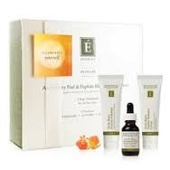
Arctic Berry Peptide Facial

What if you could target aging and hyperpigmentation, as well as sensitive, rosacea and acne prone skin in just 3 steps? Now you can do all that and awaken your skin's inner beauty with the Arctic Berry Peel & Peptide Illuminating System from Eminence Organic Skin Care.

Transformation begins with an active exfoliation from the Enzyme Exfoliant, followed by the Pro Advanced Peel Activator MA20 (multi-acid 20%), a naturally-derived activating peel. Each work in harmony with the exclusive Peptide Radiance Cream to reveal the skin's true luminosity. Featured in this collection, an exquisite blend of arctic berries, lingonberry seed oil and hibiscus seed extract target all skin concerns to give skin a new lease on life. It's your time to discover smooth, even and luminous skin.
For optimum results, four professional treatments are recommended over a sixteen week period, in combination with the Arctic Berry Peel & Peptide Illuminating System at-home kit. Incredible results are seen in just 4 weeks:

• Restores radiance 80%
• Reduces fine lines and wrinkles 80%
• Reduces dark spots 80%
• Improves dullness 100%

Reserve an Arctic Berry Peptide Facial and receive the home care recipe & samples for free.
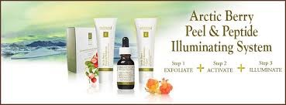
$155 Reserve Now!

Keep your skin radiant in-between spa treatments with this innovative three-step peel and peptide system which awakens the skin’s natural inner beauty using an exquisite blend of arctic berries, lingonberry seed oil and hibiscus seed extract.
Purchase Now! $135.99
http://www.avenuespastore.com/categories.asp?cID=148

Raving Fans

Total Relaxation & Pampering!
While I have stayed at The Avenue Inn several times over the years, this is my first time to the spa. I booked a 60-minute massage without looking at the menu and was able to get an appointment later that day. I arrived a bit before my scheduled time and was brought to a lounge area where they offered tea, water, and champagne and had a very relaxing quiet space where I filled out a one-page form about my health and needs. My massage therapist soon arrived, guided me to a room and asked me questions about what I do, my concerns, what type of pressure, I like, etc. I was offered some add-on packages, since I was dealing with sinus issues I went with the headache treatment ($15 additional) and one concentrating on feet (another $15). The room was cozy - not too warm, dim lights, and the table was heated. The massage was by far the best one I have ever had. She applied the perfect level of pressure, wasn't too chatty but asked questions to ensure I was having a good experience, was respectful and positive. After, she waited outside the door for me with a glass of water and a heated shoulder wrap & then she walked me around the retail space showing what she used and suggested I try (no hard sales pressure, it felt more informative). I was allowed to relax in the lounge area after for as long as I wished, and again was offered tea, water, and champagne. The whole experience was relaxing, I felt pampered, and cared for. This will NOT be my last visit! Reviewed by jetsettinallie ( Trip Advisor)

Luxury Weekend!
My wife and I came here as part of our weekend away and I have to say that this place is among the best spas that we have ever come to! We had a couples massage and several other treatments over the weekend. Every staff member, from the front of the store to the therapists, were experienced, attentive, and really nice. If you are anywhere near Rehoboth, I would highly recommend Avenue Apothecary! Reviewed by Daniel J ( Trip Advisor)

Great Ahh Massage! 5 stars
I love a deep tissue massage after a long week of working & working out. Unfortunately, the massage therapist I loved was not available to do my massage. The front desk personal suggested that I try Abigail. Hesitantly, I agreed. It was a great experience. She constantly asked if the pressure was ok, she snuggled my feet into put warm booties & listened intently to the areas of need I wanted her to work on for my aching body. Abigail was pleasant, professional, & easy to talk to. I felt great, refreshed is a better word, when I left. I would recommend Abigail if you are looking for deep tissue work. I'm sure she is great w/ Swedish as well. The owners are always so nice when I walk in. Reviewed by Maryellen M ( Trip Advisor)

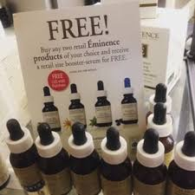
Spa Director’s Pick

It only happens once a year!
Purchase any 3 full size Eminence Organics products and receive a FREE full size Booster Serum!
Choose :

Bright Skin-Lighten & Brighten

Calm Skin-Reduce Redness

Clear Skin-Fight Acne

Firm Skin_ Hydrate & Tighten

while supplies last, limited quantity. Purchase Now!
http://www.avenuespastore.com/categories.asp?cID=16



Gift Ideas for Mother's Day

Moms are always taking care of their children, loved ones and family members. Rarely, they do things for themselves. If you don’t know what to get mom, this article will help! Best part is most of this is available right in our own Apothecary Boutique.

- A Stay-Healthy Gift: You can give her the gift of Health and Wellness by filling a gift box with a spa certificate for a deep relaxation massage, a bottle of vitamins or supplements, a healthy eating recipe book, a package of herbal tea and a Yoga DVD.

- The Beauty Bundle: You can fill an attractive gift box with Jane Iredale cosmetics, a gift certificate for an Organic facial, manicure and pedicure, relaxing lavender herbal bath, a bottle of energizing citrus body spray, Neuma a top rated organic hair care system and a set of luxurious organic cotton or bamboo sheets.

- Fitness Tote Bag: Make sure she has a place for all of her exercise items by giving her a sleek fitness tote. Inside, you can put a yoga mat, a cooling headband, a certificate for a trial gym membership, an easy-grip thermal water bottle and an iPod with a comfortable pair of ear buds so she can rock out to her favorite tunes while working up a sweat.

- Time With You: Going out for Tea Time at a nearby hotel and enjoying an afternoon together is ideal. Finish the day by visiting Avenue Apothecary & Spa for a great spa experience!

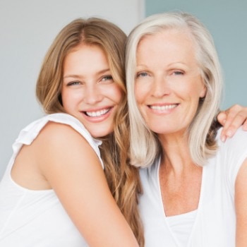

Whatever gifts you decide to choose for the wonderful mom in your life this Mother's Day, giving her the gift of Health and Wellness will help her look and feel beautiful while letting her know you care!

May Promotion : Purchase any 2 full size Kneipp products & receive a FREE GIFT SET!
While supplies last, limited quantity. Call to order 302-227-5649

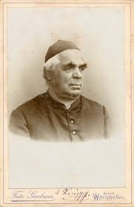

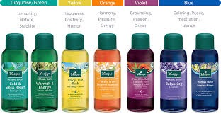
Back in the 19th century, nestled deep in the heart of Germany, Sebastian Kneipp (1821-1897), a naturopath and priest, cured himself of a severe case of tuberculosis using the very nature around him, combined with cold and hot water therapies (hydrotherapy). At that time, the disease was usually fatal, but Kneipp came across an eighteenth-century book about hydrotherapy that inspired him to immerse himself several times a week in the icy Danube River. These brief exposures to cold water seemed to bolster his immune system, sending his disease into remission.
Miraculously cured, he began his quest to provide all people a simple plan to improve and maintain good health with the healing powers of water combined with plants and herbs. Sebastian was famously known as a healer. Thousands of people visited him in the foot hills of the German Alps to learn his naturopathic methods and to be "cured".
Sebastian Kneipp became friends and close partners with a Würzburg pharmacist who shared his conviction using naturopathic medicine and healing remedies. Using only natural plant essences and pure ingredients as a base, they created the formulas that still live on today in an extensive range of bath and body treatments, now with an international cult following.
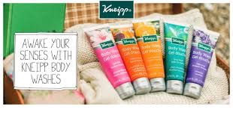
Kneipp®- made in Germany, with caring and holistic methods.


Renewal For The Mind & Body
In our busy lives filled with work and family obligations as well as daily stressors, it is easy for us to forget to take the time to renew our bodies and our minds. But, renew it we must! This is the key to restoring and maintaining the balance of our physical, mental and emotional well being.

“Every day brings a choice: to practice stress or to practice peace.” ~Joan Borysenko

Without continuous renewal of these three aspects on a regular basis, you will eventually succumb to the negative reactions caused by stress: anxiety, anger, disappointments, regret and feeling overwhelmed. The proven way of reversing this is to begin incorporating de-stressing activities and mindsets into your daily life.

- Revitalize - Disconnect yourself from all electronic devices and distractions. Schedule blocks of time to relax your mind and body…take a peaceful walk outside and breathe in the fresh air, meditate in a quiet room in your house or do a relaxing activity that makes you feel happy.

- Appreciation - Take a few minutes each day to remind yourself how much you appreciate (and are grateful for) the positive things in your life. Declare to yourself how you have the spiritual and emotional strength to overcome obstacles or stressors you encounter in your daily life - believe the affirmations that you make.

- Laughter - Be sure to incorporate humor and silliness into your life as much as possible! Studies show when a person laughs and is experiencing true joy, their body releases oxytocin - a hormone that neutralizes the effect the stress hormone cortisol has on the body and mind. Watching comedies, talking with people who make you laugh or reading a funny book are ways to get you laughing and smiling!

Thought processes and activities that renew are very beneficial to your mental, physical and emotional well-being. It is important to take care of yourself so you can enjoy life to its fullest while equipping yourself to handle any curve balls life throws your way.

Need help? Contact Avenue Apothecary & Spa today to help you live a more balanced life.

Spa Recipe
Healthy & Delicious Salad Recipe
It's surprisingly easy to prepare delicious, healthy salads for yourself or for any occasion! There are a variety of salads requiring minimal prep time. Many of them require no cooking at all! So what are you waiting for? Try the delicious and nutritious salad recipe below - it will tantalize your taste buds while filling your body with healthy goodness!

Cucumber, Tomato & Avocado Salad
This is a refreshing and easy salad to make during the summer, or anytime!

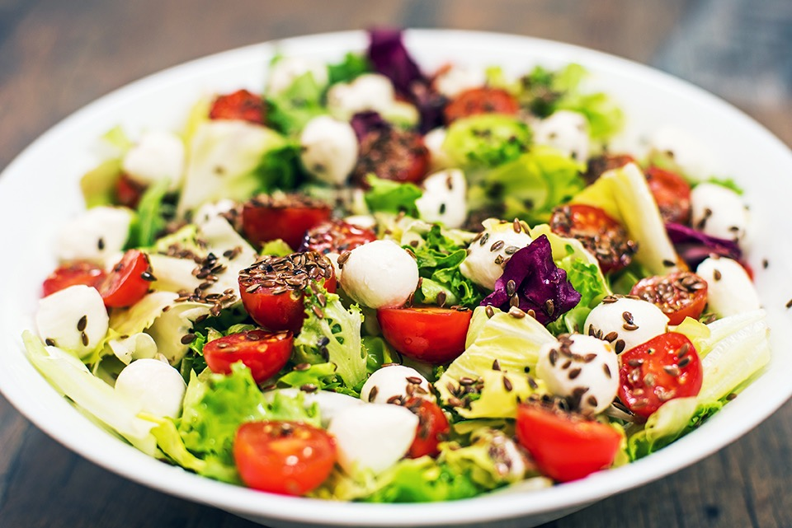
PREP TIME:12 MINS - TOTAL TIME:12 MINS - SERVES: 2 TO 4

INGREDIENTS
- 1½ cups of chopped tomatoes or cherry tomatoes
- 1 cucumber - peeled and seeded then diced
- 1 avocado - diced
- 4 oz feta cheese - cubed
- 2 tbs minced red onion
- 1 handful parsley - minced - about 2 tbs
- 2 tbs olive oil
- 1 tbs red wine vinegar
- 8 twists of black pepper from a pepper mill
- A sprinkle of Sesame Seeds

INSTRUCTIONS
- Chop tomatoes into a medium dice. If using cherry tomatoes, cut them in half. Add to a bowl.
- Peel and seed one cucumber and dice. Add to bowl.
- Remove pit, dice avocado and using a spoon scoop out the avocado from the peel. Add to bowl.
- Cube feta and add to bowl.
- Add minced red onion and minced parsley to bowl.
- Whisk together olive oil, red wine vinegar and black pepper - pour over salad.
- Toss gently so the feta and avocado don't break up. Serve immediately.
- If refrigerating - keep the avocado aside and add before serving.
Enjoy!


Last, but definitely not least ! Thanks you to all who have served this country & protected our freedom.

See you soon at Avenue Apothecary & Spa!

